PRESS RELEASE SIARAN PERS

COMMUNICATIONS AND MEDIA TEAM OF THE 43RD ASEAN SUMMIT 2023

No.06/SP/TKM-ASEAN2023/ENG/8/2023

Soekarno-Hatta Immigration Office Readies Checkpoint Facilities to Support 43rd ASEAN Summit

Jakarta, 29 August 2023 – Class I Immigration Office for Soekarno-Hatta Tangerang Special Immigration Checkpoints (TPI) is preparing several special integrated immigration crossing facilities.

This measure was taken as an effort to support the successful organization of the 43rd ASEAN Summit, which will be held on 5-7 September 2023 in Jakarta.

Head of the Soekarno-Hatta Special Class I Immigration Office TPI, Muhammad Tito Andrianto, said that the provision of the special facility was to ensure the smooth inspection of ASEAN Summit delegates given the high traffic of travelers at Soekarno-Hatta Airport.

"We provide several facilities to welcome the arrival of the 43rd ASEAN guests and delegations includingMobile Unit Border Control Management devices for delegations of head of state/ministerial level," he said in Tangerang on Tuesday (29 August).

These special immigration facilities are deployed at Terminal 3 and Terminal I Commercial Important Person (CIP) at Soekarno-Hatta International Airport.

"It’s necessary to provide these facilities to support the inspection of delegates amid high regular passenger traffic," he said.

He also emphasized that as the main and busiest entry gate in Indonesia, Soekarno-Hatta Immigration has experience in providing special facilities at every international event.

"For the 43rd ASEAN Summit in particular, we prepare the immigration services similar to that of the G20 Summit in 2022," he said.

The theme for Indonesia’s ASEAN Chairmanship 2023 is "ASEAN Matters: Epicentrum of Growth". Through this theme, Indonesia wants to ensure that ASEAN is not only an organization playing a role in the region but also in the world.

Indonesian President Joko Widodo is to open and chair 12 meetings. The series of meetings are the 43rd Summit sessions in plenary and retreat formats, the 26th ASEAN-China Summit, the 24th ASEAN-South Korea Summit, the 26th ASEAN-Japan Summit, and the 11th ASEAN-United States Summit.

The other meetings are the ASEAN-Canada Summit, the 26th ASEAN Plus Three Summit, the 20th ASEAN-India Summit, the 3rd ASEAN-Australia Summit, the 18th East Asia Summit (EAS), and the 13th ASEAN-Union Summit. Nations (UN) (Azmi Syamsul/TR)***

For more information, please contact:

Director General of Public Information and Communications of the Ministry of Communications and Informatics - Usman Kansong (0816785320)

Get other information at http://asean2023.id, https://infopublik.id/kategori/asean-2023, and https://indonesia.go.id/kategori/ragam-asean-2023

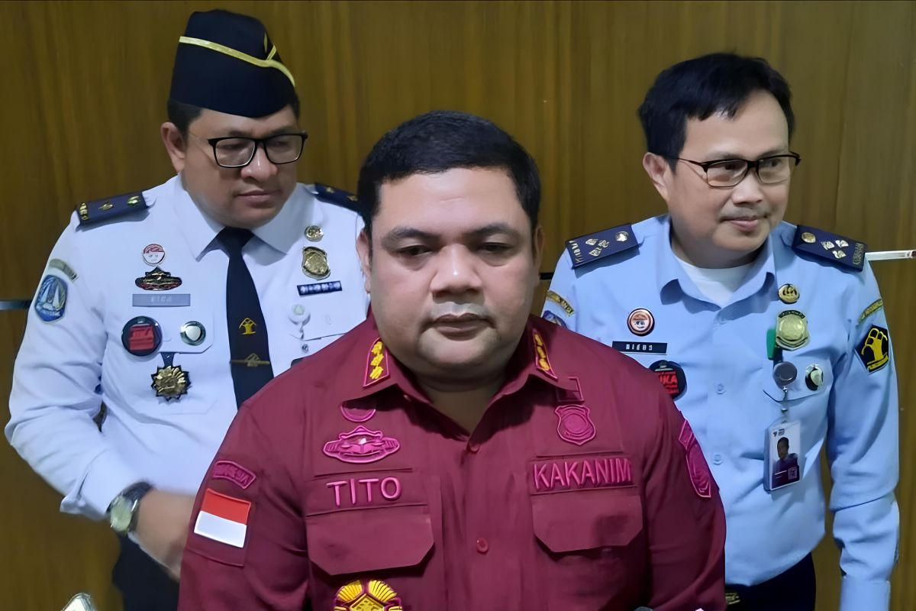

Head of the Soekarno-Hatta Special Class I Immigration Office TPI, Muhammad Tito Andrianto, said that his party was preparing several special integrated immigration crossing facilities to support the 43rd ASEAN Summit 2023.

